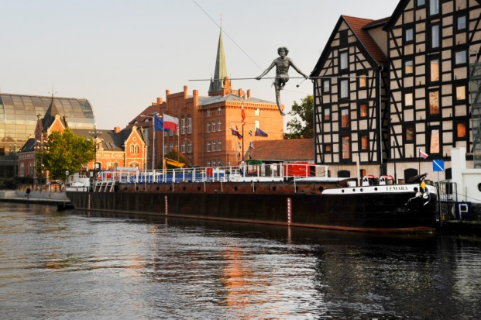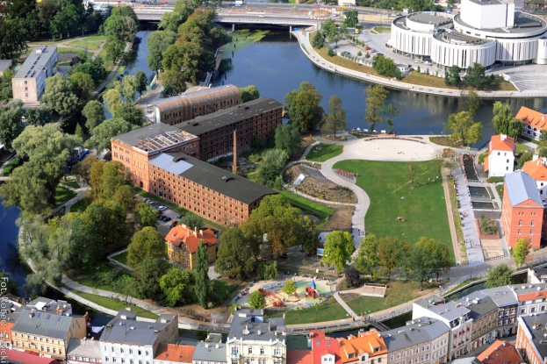
Granaries and Man Crossing the River Sculpture  by Robert Sawicki | Mill Island by Robert Sawicki

Conference of FORGET HERITAGE project
under the title „Link among citizens, policy makers and CCIs, with reference to innovative legislation, policies and ICT tools”

Bydgoszcz, 12 September 2017
Venue: Holiday Inn Bydgoszcz, 36 Grodzka Street, Bydgoszcz, Poland

PROGRAMME

08.30-09.00 Registration and refreshments
09.00-09.30 Greetings:
- representative of City of Bydgoszcz – tbc
-

09.30-10.30 Forget Heritage presentations by project partners:
a) Forget Heritage project presentation (general) – Ilaria Pittaluga, LP,
City of Genova (Italy)
b) Presentation of Forget Heritage tools:
- Guidelines for the citizens involvement in historical sites valorisation - Ilaria Pittaluga, LP, City of Genova (Italy)
- Management Manual – Chris Herrmann, Urban Lab Nuremberg, Germany
c) Presentation of ongoing activities regarding the Forget Heritage App/digital tool to involve citizens in the historical sites mapping and enhancing new uses of the sites – Tadeja Bučar, Creative Leader at PUNKT, Slovenia
d) Presentation of the structure/content of Forget Heritage Policy Handbook tool (with an overview on national/local legislation collected by project partners
- common points, differences, etc.) – Chris Herrmann, Urban Lab Nuremberg, Germany

10.30-11.00 Coffee break

11.00-12.30 - The Management of Immovable Cultural Property under Polish Law: Current Practices and Challenges - Alicja Jagielska-Burduk (PhD), University of Kazimierz Wielki in Bydgoszcz, Poland

- The Settlement of International Cultural Heritage Disputes: Plurality of Actors, Diversity of Interests - Kristin Hausler, Dorset Senior Research Fellow in Public International Law at British Institute of International and Comparative Law (BIICL), United Kingdom

- Cultural Heritage Management in the European Legal Space: A Private Owner’s Perspective - Andrzej Jakubowski (PhD), Institute of Law Studies of the Polish Academy of Sciences, Warsaw, Poland

12.30-13.00 Coffee break

13.00-13.30 - Cultural Heritage and Sustainable Development: Economy, New Technologies and Innovative Cultural Policies - Alicja Jagielska-Burduk (PhD), University of Kazimierz Wielki in Bydgoszcz, Poland and Andrzej Jakubowski (PhD), Institute of Law Studies of the Polish Academy of Sciences, Warsaw, Poland
13.30-14.00 Round table – with discussion on the Policy Handbook, comments and debate from relevant speakers
Alicja Jagielska-Burduk, UKW Bydgoszcz, Poland; Andrzej Jakubowski PAN, Poland; Kristin Hausler, BIICL, United Kingdom; Ilaria Pittaluga (Lead Partner) City of Genova (Italy); Tadeja Bučar, Creative Leader at PUNKT, Slovenia; Damjan Kavaš, Slovenia and Chris Herrmann, Urban Lab Nuremberg, Germany

Questions & answers, conclusions

14.00-15.00 Lunch

14.00-14.15 Press conference

15.00- 18.30 Study visit no. 2:
- Museum - Exploseum (Museum in former nitroglycerine fabric)
- Bydgoszcz Art Center (tbc)
- The Pomorzanin Cinema - Reawaken! (tbc)

